Pioneering Pixels: The Genesis of Computer Animation and Digital Art at Bell Telephone Laboratories

Introduction: The Epistemological Shift in Information Display
In the early 1960s, the trajectory of computational science underwent a profound metamorphosis at Bell Telephone Laboratories in Murray Hill, New Jersey. Originally engineered to execute complex numerical calculations, process ballistics trajectories, and optimize telecommunications routing, the mainframe computer was abruptly repurposed as an engine for dynamic visual synthesis.¹ This transition was not merely a convenient technological upgrade; it represented a fundamental epistemological shift in how human beings interacted with, processed, and understood vast quantities of data. As high-speed digital computers, such as the IBM 7090 and 7094 series, became capable of executing millions of operations per second, they precipitated what researchers colloquially referred to as a "data flood"—an overwhelming deluge of continuous alphanumeric output that vastly exceeded the cognitive processing bandwidth of human analysts.³
The solution to this data flood emerged at the intersection of electrical engineering, higher mathematics, visual psychology, and experimental art. Researchers at Bell Labs recognized that by translating raw numerical matrices into sequences of geometric visualizations, and subsequently recording these visual states onto motion picture film, the human visual cortex could intuitively grasp complex physical and mathematical behaviors that would otherwise remain opaque within stacks of printouts.³ This realization birthed the discipline of computer animation.
Between 1963 and 1969, an unprecedented convergence of scientific inquiry and avant-garde aesthetics took place within the industrial laboratories of Bell Labs.¹ Engineers such as Edward E. Zajac and Kenneth C. Knowlton developed the foundational software architectures and optical pipelines that allowed computers to render moving images.³ Simultaneously, perceptual researchers like Leon Harmon investigated the physiological limits of human vision through digital image processing, leading to the invention of digital halftoning, gray-scale synthesis, and algorithmic photomosaics.⁶ These technical breakthroughs rapidly attracted the attention of the artistic avant-garde, culminating in historic collaborations with experimental filmmakers like Stan VanDerBeek and Lillian Schwartz.⁸ Through the development of Domain-Specific Languages (DSLs) for graphics, Bell Labs democratized the mainframe, transforming it from a hermetic calculator into a revolutionary medium for both scientific visualization and contemporary art.¹⁰
This exhaustive report provides a granular analysis of the pioneering computer movie sources originating from Bell Telephone Laboratories. It dissects the mathematical models of early satellite simulations, the programmatic architecture of the first animation languages, the perceptual psychology underlying early gray-scale synthesis, and the profound cultural impact of the resulting digital artworks that redefined the boundaries between the mechanical and the aesthetic.

The Mathematical Foundation: Orbital Dynamics and the Gravity-Gradient Model
The genesis of computer animation is inextricably linked to the aerospace challenges of the Cold War era. In the early 1960s, Bell Labs was deeply engaged in the design of passive gravity-gradient attitude control systems for communication satellites.¹¹ The core principle of a gravity-gradient system relies on the physical reality that the Earth's gravitational field varies slightly over the length of an orbiting body. This minute variation generates torques that can be mathematically exploited to keep a satellite's axis of minimum inertia perpetually pointing toward the Earth, ensuring that communication antennas remain properly oriented without the need for active fuel expenditure.¹¹
However, because these gravity-gradient torques are extraordinarily weak—typically scaling on the order of , where represents the moment of inertia and represents the orbital rate—satellites require significant inertia augmentation to withstand environmental disturbances in orbit.¹¹ These disruptive forces include solar radiation pressure, magnetic torques interacting with the satellite's residual magnetic moment, micrometeorite impacts, and the thermal bending of structural components.¹¹
To achieve this necessary inertia augmentation, engineers designed a system featuring a long extensible rod (such as a 60-foot STEM rod) terminating in a heavy tip mass (e.g., 20 pounds).¹¹ To damp out transient perturbations and stabilize the satellite, the system incorporated two single-degree-of-freedom (single-axis) gyros acting as an internal dissipative joint or "anchor".¹¹ These gyros were housed in gimbal cans mounted on bearings and immersed in a highly viscous fluid bath; energy dissipation was achieved strictly through the fluid shear resulting from the relative motion between the gimbal cans and the satellite body.¹¹ Because of their compact size, these dissipative joints were sealed entirely inside the satellite, isolating them from the harsh vacuum and thermal extremes of the space environment.¹¹
Edward E. Zajac, a mathematician and engineer at Bell Labs, alongside his colleague J.A. Lewis, undertook the formidable task of mathematically modeling this specific two-gyro "roll-vee" configuration.¹¹ Their analytical study, subsequently published in the Bell System Technical Journal in 1964, required the computation of massive differential equations divided into two primary kinetic regimes: small-angle motion and large-angle motion.¹¹
For small-angle motion, the researchers developed linearized equations to govern the minor roll, pitch, and yaw perturbations of the satellite. The standard axes were defined geometrically: the pitch axis was normal to the orbit plane, the yaw axis lay along the local vertical (Earth-pointing), and the roll axis followed the orbital track.¹¹ The gyros were configured to provide three-axis damping. Pitch disturbances caused the gimbals to move in opposite directions (a "scissoring" motion), while yaw disturbances caused in-phase motion.¹¹ Roll disturbances, while restricted from moving the gyros directly, were damped indirectly through dynamic coupling with the yaw axis.¹¹ Zajac and Lewis wrote a computer program utilizing the Routh stability criteria to rapidly calculate the system's stability and establish rigorous mathematical bounds on the asymptotic damping rate () across a wide six-parameter space.¹¹
The large-angle motion studies were significantly more complex, addressing the highly nonlinear dynamics of a satellite far from its desired orientation, such as during initial orbital injection or deliberate inversion maneuvers.¹¹ To avoid the mathematical singularities (gimbal lock) inherently associated with Euler angles, the researchers modeled the kinematics using direction cosines and Euler parameters.¹¹ Furthermore, the system had to account for variable inertia during the physical deployment of the extensible rod in space. This required calculating the angular momentum for a body of variable mass distribution via the specific integral: where represents the radius vector from the center of mass to the mass element .¹¹
A critical component of this large-angle study was addressing the satellite's inherent bistability—meaning it possessed two stable orientations 180° apart about the pitch axis.¹¹ The researchers formulated the "Roll-Gyro Equilibrium Theorem," proving that for a symmetrical, gravity-oriented, roll-gyro-stabilized body in a circular orbit, equilibrium positions mandate that the body roll axis be parallel to either the orbit roll axis or the orbit yaw axis.¹¹ To prevent the satellite from settling into undesirable, skewed equilibrium positions due to physical gimbal stops, Zajac established that the parameters had to satisfy strict inequality conditions, such as , where is the gyro angular momentum and is the satellite inertia differential.¹¹

The Genesis of Scientific Visualization: Zajac's Orbital Simulation
The output of these exhaustive mathematical simulations was physically staggering. The numerical integration of highly nonlinear differential equations across thousands of discrete orbital time steps resulted in towering stacks of punch cards and continuous-form line printer outputs detailing the temporal histories of the satellite's pitch, yaw, and roll.³ For a human engineer, interpreting this alphanumeric "data flood" to determine if a specific multi-variable satellite configuration would ultimately stabilize or tumble wildly was agonizingly inefficient.³
Zajac recognized that the human mind processes complex spatial and temporal relationships far more effectively through continuous visual tracking than through discrete numerical reading.¹² He hypothesized that the mainframe could be explicitly programmed to calculate the perspective coordinates of the satellite's orientation at each time step, automatically draw it, and output the sequential results as a motion picture.³
In 1963, utilizing the computational power of the IBM 7090 mainframe at Bell Labs, Zajac successfully produced Simulation of a Two-Gyro Gravity-Gradient Attitude Control System—recognized historically as the first computer-animated film.⁵ The technical pipeline developed by Zajac for this film was revolutionary, establishing the foundational architecture for all modern scientific visualization.

The Hardware and Software Pipeline
The creation of the 1963 film necessitated bridging several distinct, room-sized pieces of mid-century computing hardware. The workflow proceeded through several rigidly defined stages:
- Programming and Input: Zajac wrote the core mathematical calculations governing the satellite's kinematics in the FORTRAN programming language.⁵ These calculations were punched onto standard IBM punch cards.⁵
- Geometric Translation: To convert raw coordinate data into a visual representation, Zajac utilized a specialized subprogram called ORBIT, authored by his Bell Labs colleague Frank Sinden.⁵ ORBIT translated the numerical orientation data into a three-dimensional perspective drawing of a rectangular box, which served as a geometric proxy for the satellite body.⁵
- Mainframe Processing: The punched cards were fed into the IBM 7090 (or the subsequent 7094 series) computer.⁵ The mainframe computed the precise two-dimensional screen coordinates for the perspective drawing for each individual frame of the proposed film, generating thousands of plotting instructions.
- Magnetic Storage: Because visual output devices could not process data as fast as the IBM 7090 could compute it, the mainframe wrote these plotting commands sequentially onto a reel of magnetic tape.³
- Optical Output via SC-4020: The magnetic tape was physically transported to a General Dynamics Electronics Stromberg-Carlson 4020 (SC-4020) microfilm recorder.⁵ The SC-4020 was a massive peripheral originally designed to rapidly print alphanumeric characters onto microfilm.¹⁰ Inside the SC-4020, an electron beam fired through a Charactron cathode-ray tube (CRT), tracing the calculated lines of the geometric box onto its phosphorescent screen.³
- Automated Filming: A 16mm motion picture camera, with its shutter permanently locked open, was mounted directly facing the CRT faceplate.³ Once the electron beam finished tracing a single frame, a digital command embedded on the magnetic tape advanced the camera's film to the next frame, preparing the system to expose the subsequent image.³

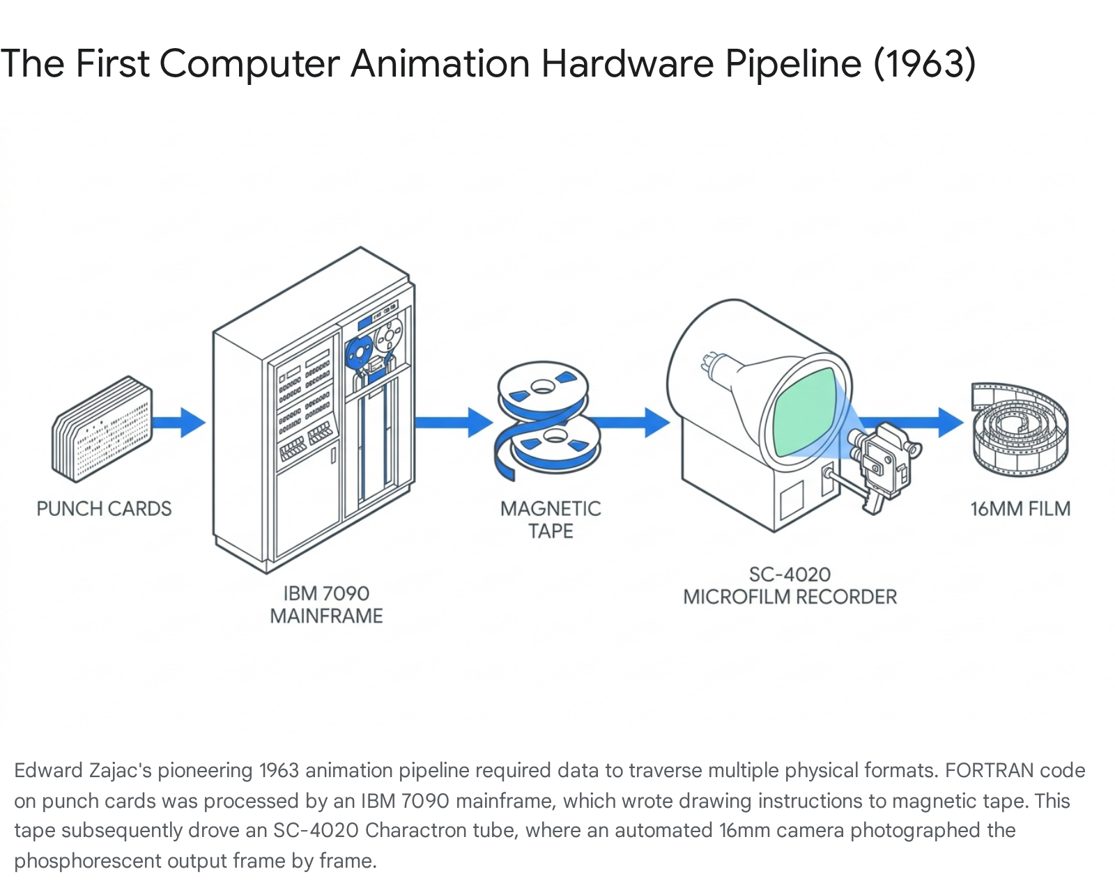

The resulting black-and-white sound film, with durations cited in historical literature ranging from a concise 1.25 minutes to an expanded 4-minute narrated version, successfully visualized the satellite orbiting a rotating Earth against a fixed-star background.³
Zajac brilliantly utilized the inherently programmatic nature of the system to manipulate cinematography in ways impossible with a physical camera. By altering merely a few data cards, he seamlessly switched the mathematical projection matrix, generating a secondary sequence from a vantage point orbiting directly behind the satellite. This alternate view omitted the Earth entirely to focus purely on the box's attitude relative to its local trajectory.³

The Philosophy of the Scientist-Filmmaker
In his subsequent foundational publications, including his 1964 paper "Computer-Made Perspective Movies as a Scientific and Communication Tool" in the Communications of the ACM and his 1965 article "Computer Animation: A New Scientific and Educational Tool" in the Journal of the SMPTE, Zajac outlined a compelling philosophy regarding this new medium.³ He championed computer animation as an "exciting, powerful, and cheap new scientific and educational tool" capable of translating esoteric physical dynamics into universally comprehensible motion.³
Zajac argued that computer animation granted the scientist unprecedented creative autonomy, transforming them into "scientist-filmmakers." By writing scripts in standard mathematical languages like FORTRAN, the scientist communicated directly through the film medium, sidestepping the need to explain complex physics to traditional cel animators.³ The inherent advantages of digital computation—specifically the use of programming loops—meant that a systematically repeating physical action only needed to be coded once, regardless of how many frames it occupied on the final reel.³ Furthermore, through parameterized variables, a single mathematical script could produce an entire "family of films" demonstrating varying physical conditions (such as different initial spin rates or mass distributions), rather than a single, static movie.³
Financially, this methodology was highly economical. Line-drawing animation generated via the SC-4020 cost approximately $50 per minute of finished film.³ This low financial barrier allowed researchers to use animation iteratively, treating the film not as a final presentation product, but as an active tool for testing hypotheses and visually debugging their physical models.³
This ecosystem rapidly expanded within Bell Labs. Following Zajac's success, F.W. Sinden produced a 10-minute educational film titled Force, Mass, and Motion, which simulated Newton's laws of gravity. Demonstrating the flexibility of the computer, Sinden easily modified the code to simulate hypothetical interactions, such as inverse-cube and direct-cube orbital relationships—scenarios that are exceptionally difficult to set up in physical experiments but trivial to simulate digitally.³ Similarly, R.N. Shepard and Zajac co-produced Two Paradoxes, a 2-minute film combining visual optical illusions (the Penrose staircase) with auditory illusions (Shepard tones), marking it as one of the first films where both the visual animation and the audio track were entirely generated by a computer algorithm.³

Early Bell Labs Computer Film | Creator(s) | Year | Primary Purpose / Innovation
Simulation of a Two-Gyro Gravity-Gradient Attitude Control System | E. E. Zajac | 1963 | First computer-animated film; visualized complex satellite stabilization mathematics via perspective graphics.³
A Computer Technique for the Production of Animated Movies | K. C. Knowlton | 1964 | Demonstrated the BEFLIX programming language; utilized typographic characters to simulate grayscale shading.³
Force, Mass, and Motion | F. W. Sinden | c. 1965 | Educational film simulating Newtonian physics, including hypothetical inverse-cube and direct-cube orbital interactions.³
Two Paradoxes | R. N. Shepard & E. E. Zajac | c. 1965 | First "pure" computer film combining algorithmic animation (Penrose staircase) with algorithmic audio (Shepard tones).³
Table 1: Key pioneering computer-animated films produced at Bell Telephone Laboratories during the early 1960s, illustrating the rapid diversification of the medium from scientific simulation to educational and psychological exploration.

Democratizing the Mainframe: Kenneth Knowlton and the BEFLIX Architecture
While Zajac’s work irrevocably proved that computers could animate mathematical models, the methodology was heavily constrained. Generating films with FORTRAN required the user to be intimately familiar with geometry, calculus, and matrix algebra to calculate the precise numerical endpoints of every line segment drawn on the CRT.³ This intense mathematical prerequisite locked computer animation behind a formidable wall of academic expertise, making it fundamentally inaccessible to traditional animators, graphic designers, and visual artists.
This paradigm was shattered by Kenneth C. Knowlton. A polymath with a background in Engineering Physics from Cornell University and a 1962 Ph.D. in Computer Science from the Massachusetts Institute of Technology (MIT), Knowlton joined the Techniques Research Department at Bell Labs and fundamentally redefined how humans instructed computers to manipulate images.¹⁵

The Invention of the Domain-Specific Language
In 1963, Knowlton developed BEFLIX (an acronym for Bell Flicks), widely recognized by computing historians as the first embedded domain-specific language (DSL) explicitly designed for computer animation.¹⁰ Introduced formally at the 1964 Spring Joint Computer Conference in his seminal 20-page paper, A Computer Technique for Producing Animated Movies, BEFLIX divorced the creation of animation from strict vector-based mathematical plotting.¹
Rather than plotting precise coordinate endpoints in an empty Cartesian space, BEFLIX was architected to simulate the raster scanning of a television set.³ It treated the computer's memory as a rigid grid of discrete picture elements (pixels). Hosted within the FORTRAN II environment and utilizing the FORTRAN II Assembly Program (FAP) macro language constructs, BEFLIX allowed users to manipulate vast visual areas rather than single lines.¹⁰
The hardware environment executing BEFLIX was formidable. The IBM 7090 was IBM's first transistor-based mainframe (a massive technological leap over earlier vacuum tube models), originally developed for the scientific, engineering, and aerospace markets, with clients including NASA and the Jet Propulsion Laboratory.¹⁰ It featured 32,768 words of magnetic core memory (utilizing 36-bit words) and a blisteringly fast memory cycle time of 2.18 microseconds.¹⁰
Knowlton brilliantly leveraged this 36-bit memory architecture. In BEFLIX, visual information was encoded at a depth of 3 bits per pixel.¹⁰ This highly efficient packing meant that exactly 12 pixels could be stored in a single 36-bit word.¹⁰ This optimization was crucial; it ensured the IBM 7090 had sufficient core memory to hold two entirely uncompressed "fine resolution" frames simultaneously in RAM, allowing for rapid frame-buffer manipulation without constantly reading and writing to slow magnetic disks.¹⁰

Surfaces, Scanners, and Logical Operations
To abstract the physical memory into something an animator could conceptualize, BEFLIX organized the core memory into logical "surfaces." The programmer could choose to work in coarse resolution (126 by 92 pixels) or fine resolution (252 by 184 pixels).¹⁰ By linking contiguous blocks of coarse surfaces, Knowlton allowed programmers to construct custom aspect ratios—from extreme horizontal panoramas to tall vertical strips—optimizing the IBM 7090's rigid structure for visual flexibility.¹⁰

Surface Designator | Resolution | Memory Allocation Topology | Valid Pairings for Extended Grids
WW, XX, YY, ZZ | 126x92 | Coarse | Standard low-resolution blocks.¹⁰
AA, BB | 252x184 | Fine | Standard high-resolution blocks.¹⁰
PP | 252x92 | Horizontal Coarse | Merges WW + XX.¹⁰
TT | 126x184 | Vertical Coarse | Merges YY + ZZ.¹⁰
FF | 504x92 | Wide Coarse | Merges WW + XX + YY + ZZ.¹⁰
EE | 126x368 | Tall Coarse | Merges WW + XX + YY + ZZ vertically.¹⁰
Table 2: The architectural memory models of the BEFLIX language. Knowlton's design abstracted the mainframe's 36-bit words into manipulable visual grids, allowing animators to specify frame buffers of varying dimensions.
To manipulate these surfaces, BEFLIX employed a conceptual mechanism called "Scanners" (named A through Z).¹⁰ A scanner functioned as a programmable read/write head that "lived" on a designated surface. It possessed a specific coordinate within the surface and could read the 3-bit value of the pixel beneath it.¹⁰ Programmers manipulated the image by conditionally directing these scanners to read, compare, move, and write pixel values.
A typical BEFLIX script relied on low-level operational logic rather than algebra. For example, the macro command PLACE sc, surf, x, y would initialize a scanner at a specific location on a surface.¹⁰ More complex logic was achieved through conditional branching, such as the IFANY command. A programmer could instruct the system with a string like: IFANY (B,R,10)(B,A,C)(A,E,7)T(A,T,B)..., which logically translates to: If scanner B is to the right of x=10, OR if scanner B is above scanner C, OR if scanner A is sitting on a value equal to 7, THEN move scanner A to the same position as scanner B.¹⁰
To demonstrate the power and efficiency of the language, Knowlton produced a 17-minute, silent instructional film titled A Computer Technique for the Production of Animated Movies (1964).³ The film served as a visual manual, showcasing macro-commands intrinsic to BEFLIX, such as PAINT, ZOOM, and DISOLV, which allowed users to manipulate entire rectangular blocks of pixels simultaneously.³ By automating repetitive tasks, providing looping structures, and abstracting the underlying memory management, BEFLIX made computer animation fundamentally accessible. While calculating the state of every single pixel point made BEFLIX films computationally more expensive than Zajac's line-drawn vector films, the language required virtually no mathematical training, opening the mainframe's doors to non-scientists and setting the stage for digital art.³

Spatial Quantization and the Psychology of Perception
While BEFLIX elegantly solved the software accessibility problem, Bell Labs researchers still faced a stringent hardware limitation that bottlenecked visual fidelity: the SC-4020 microfilm recorder was an inherently binary output device.⁶ Its Charactron tube was designed to expose film microscopically as either solid black or solid white. It completely lacked the analog capacity to modulate the intensity of its electron beam to produce continuous-tone shades of gray.³
Knowlton initially circumvented this limitation in his 1964 BEFLIX film through a rudimentary form of typographic mapping. Because the Charactron tube was optimized to stamp alphanumeric characters onto the screen rapidly, Knowlton used visually dense letters (like the letter "B" or "M") to represent dark shades, and sparse punctuation marks (like commas, apostrophes, or periods) to represent lighter areas.³ While functional for instructional diagrams, this technique was visually crude.
However, this rudimentary typographic mapping sparked a much deeper, scientifically rigorous inquiry into spatial quantization, dithering, and digital halftoning. Working alongside Leon D. Harmon—a brilliant researcher specializing in mental and neural processing, who had previously worked with John von Neumann on the IAS machine—Knowlton sought to formally define the algorithms necessary to derive subjective gray values from strictly binary output devices.⁶

The Algorithmic Deconstruction of Tone
Harmon and Knowlton's collaborative research, eventually formalized in seminal papers published in the journals Computer Graphics and Image Processing (1972) and Visible Language (1977) under the title "Computer-Produced Grey Scales," represented a monumental leap in digital image processing.⁶ They developed sophisticated computational techniques to quantize physical space into discrete micro-cells, filling these cells with varying sizes and shapes of black areas on a white background.⁶
The concept of halftoning was not entirely novel; historical precedents stretched back to Henry Fox Talbot's 1852 patent utilizing folded black crape gauze for photographic engraving, and even earlier to 1827 punch-card operated looms capable of weaving black and white silk threads into continuous-tone images with a resolution of 125 threads per inch.¹⁸ However, Harmon and Knowlton were pioneering the translation of this analog concept into the digital realm, utilizing iterative screen design and computational algorithms to achieve optimal visual fidelity without human intervention.¹⁸
Their algorithms divided the image grid into specific classes of black and white regions, utilizing pseudo-random noise and ordered dither matrices to artificially smooth out tonal discontinuities and break up harsh quantization steps.⁶ This allowed a purely binary output device to trick the human eye's physiological limitations, coercing the visual cortex into perceiving a rich, continuous gradient of gray from a field of stark black and white pixels.⁶

Studies in Perception I (Computer Nude)
The most famous, and historically consequential, application of these grayscale synthesis algorithms occurred in 1966. Harmon and Knowlton were actively experimenting with photomosaic techniques, testing how the human brain integrates small, seemingly unrelated micro-patterns into a coherent macro-image.⁷
For their test subject, they selected a photograph of the avant-garde dancer and choreographer Deborah Hay, reclining nude.⁷ The digitization process was painstaking. They scanned the original photograph with an optical camera, which converted the analog light voltages into discrete binary numbers. These numerical values were then processed by their spatial quantization algorithms and mapped to a specialized set of typographic symbols—ranging from mathematical operators to custom geometric blocks—based precisely on their calculated halftone densities.⁷
The resulting output was printed as a massive 12-foot-wide (150 x 370 cm) mural, titled Studies in Perception I (Computer Nude) (1966/1967).⁷ Initially characterized by Knowlton as a "sophomoric prank" meant to be secretly hung in the office of a Bell Labs executive, the piece was actually a rigorous demonstration of physiological visual theory.⁷
The composition illustrated the unique ability of the viewer's brain to interpret abstract symbols. Upon close inspection, the mural dissolved into an incomprehensible matrix of electronics symbols, letters, and glyphs. However, as the viewer stepped back, increasing the physical distance, the brain seamlessly integrated the varying micro-densities of the symbols into the smooth, continuous macroscopic curves of the human form.²⁰

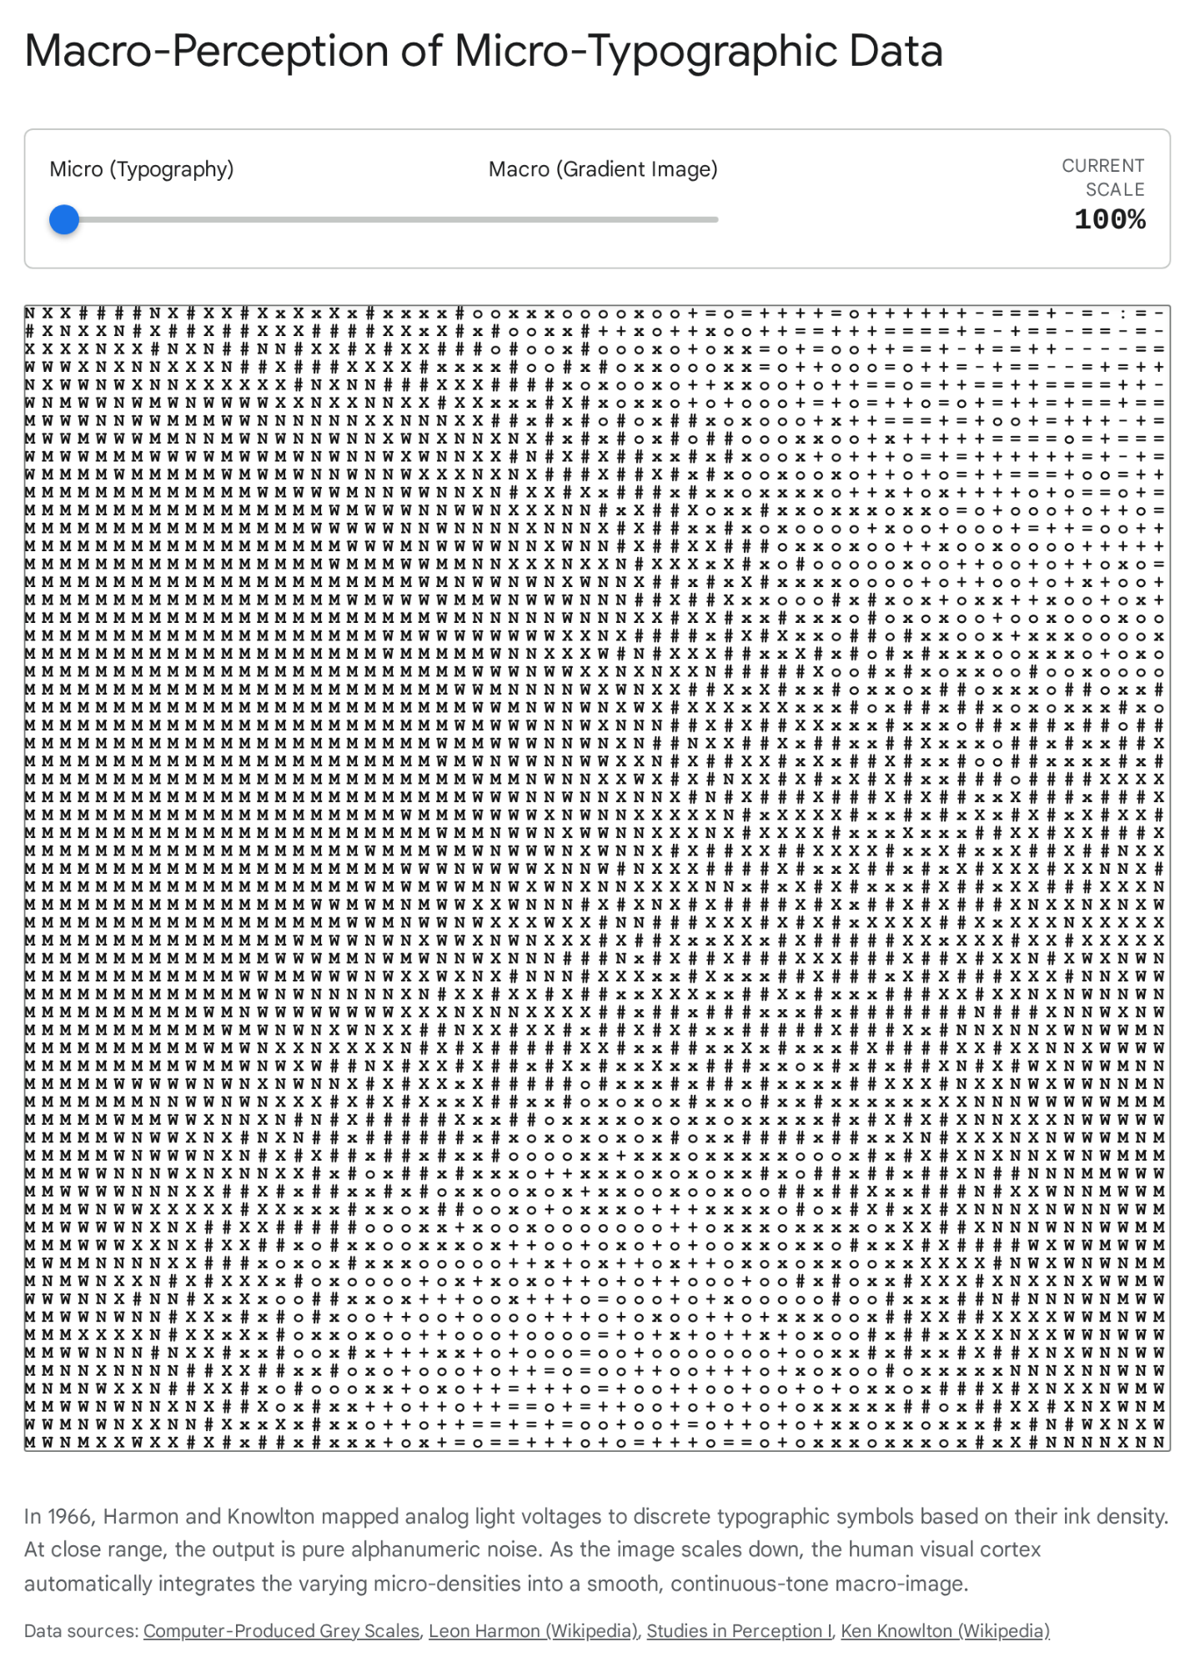

The cultural and scientific impact of this specific work was immense. It was published in The New York Times on October 11, 1967—making history as the first full-frontal nude published by the venerable paper—instantly vaulting computer graphics into the broader public consciousness.⁷
The success of the nude mural deeply informed Leon Harmon’s subsequent, highly influential research into facial recognition. Harmon sought to determine the absolute minimum amount of spatial and tonal information required for the human brain to recognize and discriminate specific human faces.²² By applying these spatial quantization techniques, Harmon produced a highly pixelated, block portrait of Abraham Lincoln, consisting entirely of varying shades of gray squares.⁷ This minimalist portrait illustrated his landmark November 1973 Scientific American article, "The Recognition of Faces," laying the theoretical groundwork for modern image compression algorithms.⁷ The image was so striking that in 1976, surrealist Salvador Dalí explicitly utilized Harmon's Lincoln portrait as the basis for his optical-illusion painting Gala Contemplating the Mediterranean Sea, representing one of the earliest instances of a recognized traditional artist directly appropriating digital algorithmic output.⁷ Harmon and Knowlton continued their specific series of perceptional studies in 1969 with the creation of Gulls (Studies in Perception II) and Gargoyle (Studies in Perception III), further cementing their legacy as pioneers of digital image synthesis.¹⁶

The Avant-Garde Incursion: Stan VanDerBeek and the Poemfield Series
The highly publicized publication of Computer Nude acted as a powerful catalyst, irrevocably drawing the attention of the New York avant-garde arts community to the sterile, industrial laboratories of New Jersey. The artwork played a pivotal role in the formal launch of Experiments in Art and Technology (E.A.T.), an influential organization founded by artist Robert Rauschenberg and Bell Labs engineer Billy Klüver specifically to foster deep collaborations between the engineering and artistic communities.⁸
Among the earliest and most visionary artists to recognize the profound potential of the computer as an expressive artistic medium was the experimental filmmaker Stan VanDerBeek.²³ VanDerBeek viewed the computer not merely as an automated drafting tool, but as a revolutionary mechanism for expressing and engaging human consciousness.⁸ During the height of the Cold War, he argued that technology was a necessary tool that humanity had to master to prevent its own mechanization and destruction.⁸ He envisioned sprawling multimedia "experience machines," culminating in his architectural concept of the "Movie-Drome"—a proto-cinematic, dome-shaped space designed to immerse audiences in a barrage of audiovisual data, eerily anticipating modern concepts of the internet, media saturation, and algorithmic curation.²³
Through mutual connections within the E.A.T. network, VanDerBeek began a formal collaboration with Kenneth Knowlton at Bell Labs in 1966.⁸ Utilizing Knowlton's BEFLIX programming language and the massive IBM 7094 mainframe, the duo produced a sequence of groundbreaking, computer-animated films known collectively as the Poemfield series (created between 1966 and 1971).⁸

Typography, Geometry, and Machine Semantics
The Poemfield series consists of eight documented films, though various historical sources and retrospectives occasionally reference up to ten.¹⁵ These works represent a radical departure from both Zajac's rigid scientific simulations and the character-driven narratives of traditional animation. They are fundamentally textual, lyrical, and abstract, exploring the deep intersection of visual poetry, typography, and machine logic.²⁴
In a typical Poemfield film (such as Poemfield No. 2), the cinema screen operates as a fluid, highly pixelated canvas.²⁶ Thousands of electrons, guided by the precise logic of the BEFLIX script, generate twinkling mosaics and kaleidoscopic geometric fields.⁸ From these abstract, shifting matrices, powerful sequences of words and poems gradually coalesce into legibility, move dynamically across the frame, and subsequently dissolve back into the digital noise from which they emerged.⁸
The text for these films was primarily sourced from VanDerBeek’s own poetry. However, in Poemfield No. 7, VanDerBeek utilized words written by the prominent nonviolent peace activist A.J. Muste.⁸ By programming these humanist, anti-war, and existential messages into the IBM 7094—a multi-million dollar mainframe whose primary clientele included NASA and the U.S. military—VanDerBeek engaged in an early form of conceptual hacking.⁸ He subverted a technology expressly designed for computing ballistic trajectories and orbital mechanics, forcing it instead to render the existential anxieties and poetic aspirations of the Computer Age.⁸
The physical process of creating the Poemfield films was arduous and highly collaborative. VanDerBeek, heavily informed by his formal background in painting, designed the visual choreography, while Knowlton translated these artistic impulses into functional BEFLIX logic.²⁶ The initial visual output was captured by the Stromberg-Carlson 4020 microfilm recorder strictly in black and white.²⁶ Because native, high-fidelity color computer graphics were not yet viable on this hardware, the vibrant, psychedelic colors seen in the final Poemfield distributions were achieved through complex, post-production optical printing and tinting processes carried out by VanDerBeek.²⁶
These experimental films were rarely exhibited in traditional cinemas. VanDerBeek distributed them individually, projected them inside his spherical Movie-Drome, and integrated them into massive, multi-screen architectural installations such as Found Forms (1969) and Cine Dreams (1972).⁸ The Poemfield series definitively demonstrated that computer programming could transcend functional utility to become a deeply expressive, poetic medium in its own right.

The Expansion of the Algorithmic Canvas: The Evolution of Domain-Specific Languages
The extraordinary success of the VanDerBeek-Knowlton partnership established Bell Telephone Laboratories as a vital global nexus for computational art.⁹ Knowlton, functioning both as a lead software engineer and a passionate champion of the digital medium, continually developed new graphics programming languages specifically engineered to facilitate artistic collaboration and push visual boundaries.⁴
By continuously analyzing the aesthetic limitations of BEFLIX, Knowlton developed a suite of subsequent Domain-Specific Languages, each providing entirely different visual affordances:
- EXPLOR (EXplicit Patterns, Local Operations & Randomness): Developed around 1970, this language was tailored explicitly for generating complex, repeating patterns and executing cellular automata logic.¹⁵ Knowlton collaborated extensively with artist Lillian F. Schwartz, who utilized the EXPLOR system to create a highly influential series of ten abstract animated films between 1968 and 1974, defining much of the early aesthetic of algorithmic art.¹⁵
- SPHERES (System For Efficient Rendering of Ensembles of Spheres): Created around 1981, this advanced system allowed for the three-dimensional rendering and intersecting of spherical objects.¹⁵ Crucially, it dealt with complex computational issues of pictorial depth, realistic roundedness, and object occlusion in 3-space.¹⁷ Knowlton collaborated with Emmanuel Ghent on the 1978 film Baobab, utilizing an early version of the SPHERES system to produce animations that dynamically responded to and were rhythmically inspired by Ghent's electronic music.¹⁵
- ATOMS (A Three-dimensional Opaque Molecule System): Developed in collaboration with L. Cherry in 1977, this system was optimized specifically for ball-and-stick rendering in chemistry visualization.¹⁷ It returned Knowlton's technology to its strict scientific roots while maintaining the high aesthetic quality developed during his artistic collaborations.¹⁷
This continuous, iterative loop of feedback—where the creative demands of avant-garde artists like VanDerBeek and Schwartz pushed Knowlton to invent entirely new programming architectures, which in turn unlocked unforeseen creative possibilities for the artists—became the defining hallmark of the Bell Labs model of industrial research.⁴ Beyond graphics, Knowlton's work in this period also yielded significant structural contributions to computer science, including the L-6 language (Low Level Linked List Language) and the "buddy system" for fast storage allocation (binary splitting and recombination of memory blocks), proving that artistic inquiry could drive fundamental computer science.¹⁷

Institutional Validation and the Museum Context
The radical visual experiments conducted at Bell Labs were not confined to scientific journals; they were rapidly absorbed into the institutional framework of the contemporary art world, securing the computer's status as a legitimate artistic tool.
The seminal moment for this high-culture validation was the landmark 1968 exhibition The Machine as Seen at the End of the Mechanical Age, curated by K.G. Pontus Hultén at the Museum of Modern Art (MoMA) in New York City.¹⁵ The exhibition sought to explore the historical relationship between art and technology, provocatively juxtaposing classical mechanical devices (such as a 1951 Bugatti Royale and a Chrysler engine fitted into a horse-drawn hearse) with the bleeding edge of the emerging digital and cybernetic era.²⁸
Harmon and Knowlton's 12-foot mural, Studies in Perception I (Computer Nude), was prominently featured in this exhibition, serving as a striking visual metaphor for the transition from the mechanical age to the information age.⁴ The image physically demonstrated how traditional, continuous analog reality (represented by the human body) was being digitized, quantized, and reconstructed by machine logic.²⁰
Furthermore, MoMA integrated the temporal dimension of Bell Labs' research into the exhibition's public programming. On the evening of November 21, 1968, MoMA's Department of Film, under the sponsorship of the International Study Center, hosted "An Evening of Computer-Produced Films".²⁷ During this 80-minute event, Kenneth Knowlton presented a comprehensive screening of computer animations generated at Bell Labs, alongside related works from the Boeing Aircraft Company, Lawrence Radiation Laboratory, Los Alamos Scientific Laboratory, and MIT.⁴ Knowlton lectured the audience on the underlying programming techniques, effectively serving as an ambassador for the new medium and demystifying the mainframe for the cultural elite.²⁷
This institutional relationship proved remarkably enduring. Exactly fifty years later, on Monday, March 26, 2018, MoMA hosted An Evening of Computer Films with Ken Knowlton as part of its Modern Mondays series.⁴ This retrospective event, held in the Roy and Niuta Titus Theater 2, was programmed in conjunction with the exhibition Thinking Machines: Art and Design in the Computer Age, 1959–1989.⁴ Original 16mm prints of Knowlton's BEFLIX-produced works and his collaborative films were screened, after which Knowlton engaged in a live conversation with writer Rebekah Rutkoff and MoMA associate media conservator Peter Oleksik.⁴ The 2018 event cemented the legacy of the Bell Labs researchers not merely as engineers who solved graphical display problems, but as foundational pioneers of a dominant global art form.⁴

Conclusion: The Synthesis of Algorithm and Aesthetics
The body of work generated at Bell Telephone Laboratories during the 1960s represents a unique singularity in the history of media and technology. The researchers did not initially set out to invent a new artistic paradigm; their primary mandate was to solve critical engineering bottlenecks associated with telecommunications and aerospace. Edward Zajac sought a mechanism to comprehend the multidimensional stabilization of gravity-gradient satellites, leading directly to the creation of the first computer animation pipeline.³ Kenneth Knowlton recognized that the steep mathematical learning curve of FORTRAN was an inefficient barrier to widespread visualization, leading to the creation of BEFLIX, the first graphical abstraction layer.³ Leon Harmon required a rigorous method to test the absolute physiological limits of human pattern recognition, leading to the algorithmic synthesis of gray scales and the invention of digital photomosaics.⁷
Yet, by solving these deeply technical, domain-specific problems, these engineers inadvertently constructed the foundational vocabulary of digital media. They proved unequivocally that a computer is not merely a high-speed calculator, but a universal simulator capable of rendering Newtonian physics, expressive typography, and the nuances of the human form. By opening their laboratories and inviting avant-garde artists like Stan VanDerBeek and Lillian Schwartz into their rigorous mathematical environments, the Bell Labs engineers ensured that this new technology was infused with humanist inquiry, poetic semantics, and aesthetic rigor.⁸ The resulting films and images—from the tumbling orbit of Zajac's satellite box to the pixelated gaze of Harmon's Lincoln and the lyrical geometry of the Poemfields—stand today not just as footnotes in computer science, but as the foundational artifacts of the digital visual age.

Works cited
- ICT & Art CONNECT - Timeline - Cheshire Henbury, accessed June 9, 2026, https://www.cheshirehenbury.com/ict-art-connect/ict-art-connect-timeline.html
- Computing Science Technical Report No. 99 A History of Computing Research* at Bell Laboratories (1937-1975), accessed June 9, 2026, http://research.google.com/pubs/archive/94.pdf
- Zajac - Content: Animation, accessed June 9, 2026, http://content-animation.org.uk/htmls/zajac_smpte.htm
- An Evening of Computer Films with Ken Knowlton | MoMA, accessed June 9, 2026, https://www.moma.org/calendar/events/4117
- Edward Zajac Produces the First Computer-Animated Film, accessed June 9, 2026, https://www.historyofinformation.com/detail.php?entryid=1002
- Computer-Produced Grey Scales | Visible Language - Journals@UC, accessed June 9, 2026, https://journals.uc.edu/index.php/vl/article/view/5226
- Leon Harmon - Wikipedia, accessed June 9, 2026, https://en.wikipedia.org/wiki/Leon_Harmon
- Poemfield - The BOX Gallery, accessed June 9, 2026, https://www.theboxla.com/artist.php?id=5703
- Technology + Art - CHM - Computer History Museum, accessed June 9, 2026, https://computerhistory.org/exhibits/technology-art/
- BEFLIX | PPTX - Slideshare, accessed June 9, 2026, https://www.slideshare.net/slideshow/beflix/71664039
- A Two-Gyro, Gravity-Gradient Satellite Attitude Control System, accessed June 9, 2026, https://www.content-animation.org.uk/htmls/lewis.htm
- New Scientist 10 February 1966 - Computer Arts Society, accessed June 9, 2026, https://computer-arts-society.com/casarchive/cas/uploads/zajac-new-scientist-1966-8.pdf
- Computer Animation: A New Scientific and Educational Tool (1965, accessed June 9, 2026, https://scispace.com/papers/computer-animation-a-new-scientific-and-educational-tool-3x27kyxpp7
- A pair of paradoxes - Database of Digital Art, accessed June 9, 2026, http://dada.compart-bremen.de/item/artwork/645
- Ken Knowlton - Digital Art Museum - DAM, accessed June 9, 2026, https://dam.org/museum/artists_ui/artists/knowlton-ken/
- Ken Knowlton - Wikipedia, accessed June 9, 2026, https://en.wikipedia.org/wiki/Ken_Knowlton
- Selected Papers - Ken Knowlton, accessed June 9, 2026, https://www.kenknowlton.com/pages/29papers.htm
- Recent Progress in Digital Halftoning - Imaging.org, accessed June 9, 2026, https://www.imaging.org/common/uploaded%20files/pdfs/Papers/1999/RP-0-93/1744.pdf
- Figure 10 from Computer-produced grey scales | Semantic Scholar, accessed June 9, 2026, https://www.semanticscholar.org/paper/Computer-produced-grey-scales-Knowlton-Harmon/07602fa0f317f7d2d4fa63b7a8a69c64d2d5d01f/figure/6
- Experiments in Art and Technology, accessed June 9, 2026, https://www.uni-weimar.de/kunst-und-gestaltung/wiki/images/EAT.pdf
- Incredible Machines: Following People Like Us Into the Database | Danny Snelson 2012, accessed June 9, 2026, https://dss-edit.com/plu/
- Convolutional Photomosaic Generation via Multi-Scale Perceptual Losses - CVF Open Access, accessed June 9, 2026, https://openaccess.thecvf.com/content_ECCVW_2018/papers/11131/Tesfaldet_Convolutional_Photomosaic_Generation_via_Multi-Scale_Perceptual_Losses_ECCVW_2018_paper.pdf
- Poemfield No. 1 - Ji.hlava IDFF, accessed June 9, 2026, https://www.ji-hlava.com/filmy/poemfield-no-1
- Stan VanDerBeek - Criticism - e-flux, accessed June 9, 2026, https://www.e-flux.com/criticism/237428/stan-vanderbeek
- Poem Field - Wikipedia, accessed June 9, 2026, https://en.wikipedia.org/wiki/Poem_Field
- Poemfield No. 2 by Stan VanDerBeek - YouTube, accessed June 9, 2026, https://www.youtube.com/watch?v=87VMJEt6Mvw
- Sound Recordings in The Museum of Modern Art Archives - MoMA, accessed June 9, 2026, https://www.moma.org/research/archives/finding-aids/SoundRecordingsf
- iThe Museum of Modern Art - MoMA, accessed June 9, 2026, https://assets.moma.org/documents/moma_press-release_326596.pdf
- Modern Mondays - MoMA, accessed June 9, 2026, https://www.moma.org/calendar/film/560

